
Lesson 13: A Hit That Reacts
TIC-80
VIDEO GAME CREATION
This week: getting hit finally LOOKS like getting hit. A brief flash, then a small explosion, before the enemy disappears.
Open your own [YourName]Game project from Lesson 12 - don't start a new one.
Important: your score, lives, wave, and win/lose logic should all still work exactly as before. Today only changes how the enemy's removal LOOKS, not when your game-state actually changes.

Setup
- Open your [YourName]Game project from Lesson 12.
- Design a small explosion sprite in the Sprite Editor (a burst/star shape works well) in an empty slot, and a second "flash" version of your enemy sprite (the same silhouette, recolored bright white) in another empty slot - note both slot numbers.

Level 1 - Minimal (MVP)
On every hit, the enemy briefly flashes, and a small independent explosion effect appears and cleans itself up. Score, lives, wave, and win/lose logic are all unaffected.
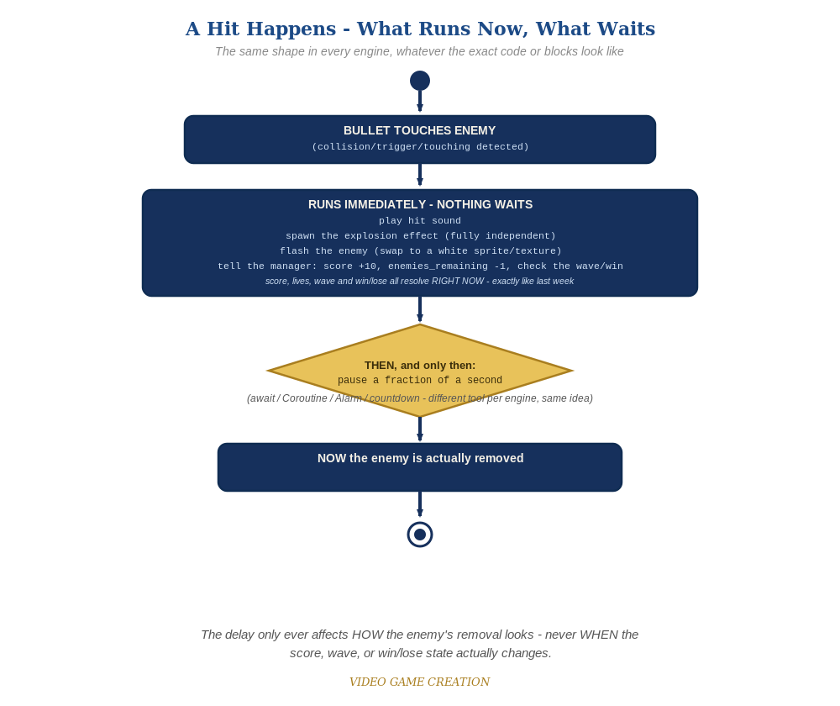
Everything in the top box happens the instant the hit is detected. Only the enemy's own removal - the very last step - waits for the pause to finish.
- TIC-80's code can't pause mid-frame, so this week's delay works differently: instead of removing a hit enemy from your enemies table immediately, give it a flash countdown field and remove it once that counter reaches 0.
- In the bullets loop's hit branch, right after the existing sound/score/win-check lines, add e.flash = 6 to the enemy that was hit (code below) - do NOT remove it from the table yet.
- Add a small explosions table, and table.insert an entry (with its own short countdown) at the hit position - this is independent of the enemy's own flash countdown.
- Add a new update loop (runs every frame, before drawing): count down every enemy's flash field and every explosion's countdown, removing each from its table once it reaches 0.
- In your drawing code, draw the flash sprite instead of the normal enemy sprite whenever e.flash is set, and draw each active explosion's sprite at its position.
- Press Esc, type run, press Enter, then play through a full round - each hit should flash the enemy briefly, and a small burst should appear at that spot for a moment.
Highlighted lines are new this week; everything else is code you already have.
-- bullets loop's hit branch (revised):
score = score + 10
enemies_remaining = enemies_remaining - 1
sfx(2)
e.flash = 6
table.insert(explosions, {x=e.x, y=e.y, t=12})
if enemies_remaining <= 0 then
if wave >= total_waves then
game_active = false
has_won = true
sfx(3)
else
wave = wave + 1
enemies_remaining = 5
sfx(6)
spawn_wave()
end
end
-- new update loop (each frame, before drawing):
for i=#enemies,1,-1 do
local e = enemies[i]
if e.flash then
e.flash = e.flash - 1
if e.flash <= 0 then table.remove(enemies, i) end
end
end
for i=#explosions,1,-1 do
explosions[i].t = explosions[i].t - 1
if explosions[i].t <= 0 then table.remove(explosions, i) end
end
-- drawing (per enemy):
if e.flash then spr(FLASH_SPRITE, e.x, e.y, 14) else spr(ENEMY_SPRITE, e.x, e.y, 14) end

Level 2 - Complete (Alpha/Beta)
The flash and explosion play correctly on every single hit, with no leftover explosions, no enemies stuck mid-flash, and no change to score/lives/wave timing.
- Play a full round: every single hit shows a flash and an explosion, with no enemy left stuck mid-flash.
- Confirm score, wave-clear, and win/lose all still happen at exactly the moments they did last week - only each enemy's actual table.remove() is delayed, not the scoring logic.
- Confirm the explosions table never grows without bound - each entry's countdown reaches 0 and gets removed on its own.

Level 3 - Refined (Ready to Publish) - pick any that interest you
- Visual: cycle the explosion through 2-3 different sprite frames across its 12-frame lifetime instead of one static sprite, for a simple hand-animated burst.
- Visual: instead of a flat flash sprite, alternate between the flash sprite and the normal sprite every couple of frames while e.flash is active, for a flicker instead of a solid flash.
- Structure: notice the explosions table knows nothing about score, lives, or waves - it's a fully self-contained piece of state, the same discipline as this course's bullets table.

If Something's Wrong
- Enemy vanishes instantly, no flash visible: confirm e.flash = 6 was actually added, and that the table.remove() for a hit enemy no longer happens in the hit branch itself.
- Enemy freezes on screen forever, never removed: confirm the new update loop is actually being called every frame from TIC(), and that it counts down and removes correctly.
- Explosion sprite never appears: confirm FLASH_SPRITE/explosion sprite slot numbers in your drawing code match what you actually drew in the Sprite Editor.

Want More?
Student Resource List > TIC-80 section, or github.com/nesbox/TIC-80/wiki

